

SIMATS ENGINEERING

Saveetha Institute of Medical and Technical Sciences Chennai- 602105
Student Name: G MANISH
Reg. No: 192210591
Course Code: CSA0315 Slot:D
Course Name: DATA STRUCTURESC
Course Faculty: Dr. T. RAJESH KUMAR

Project Title: ONLINE COURSE REGISTRATION AND MANAGEMENT SYSTEM
Module Photographs: (3 photographs –Module Photo, Individual student contribution module work in the project and presentation image)
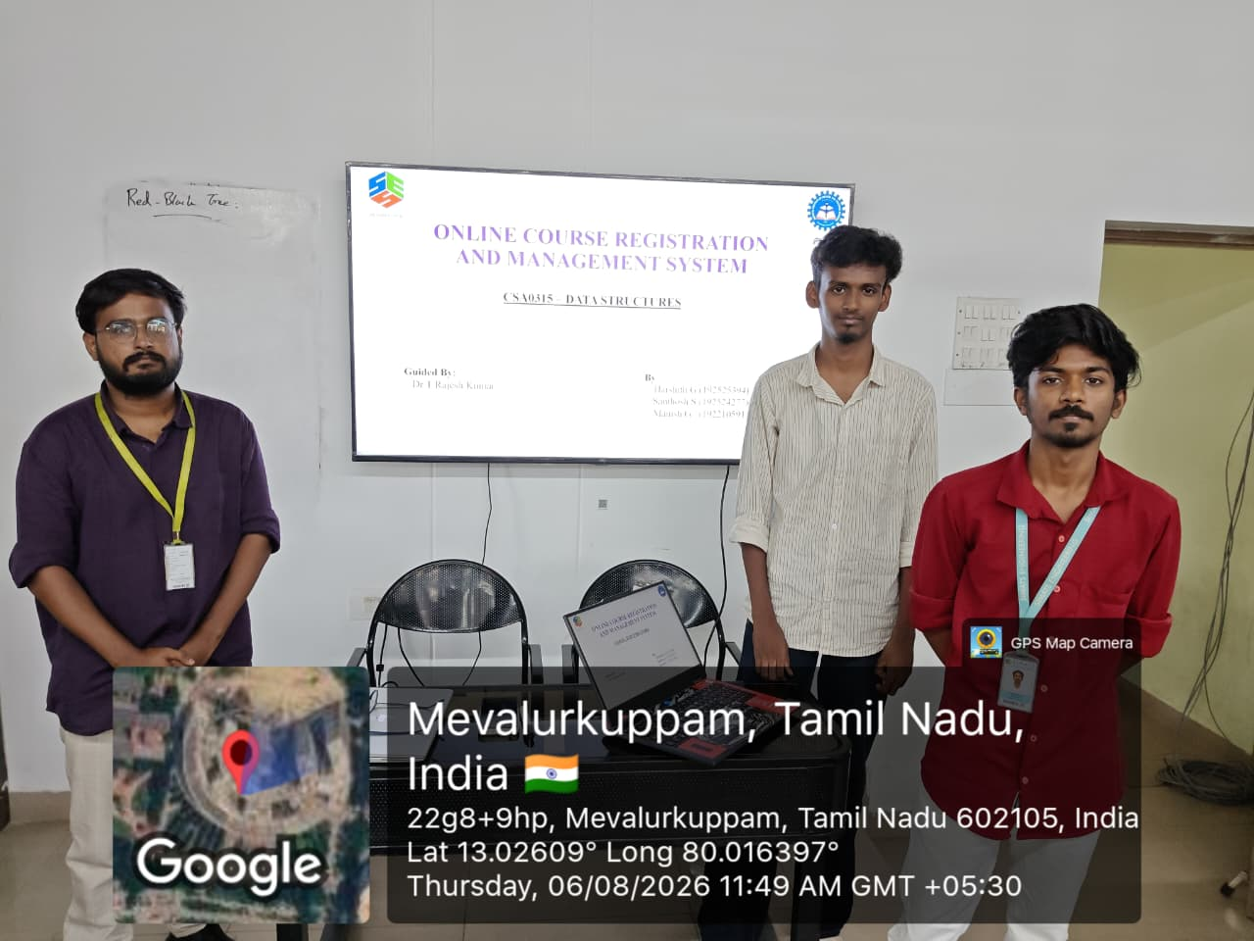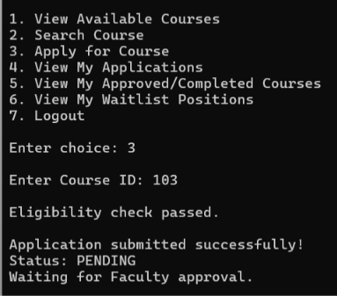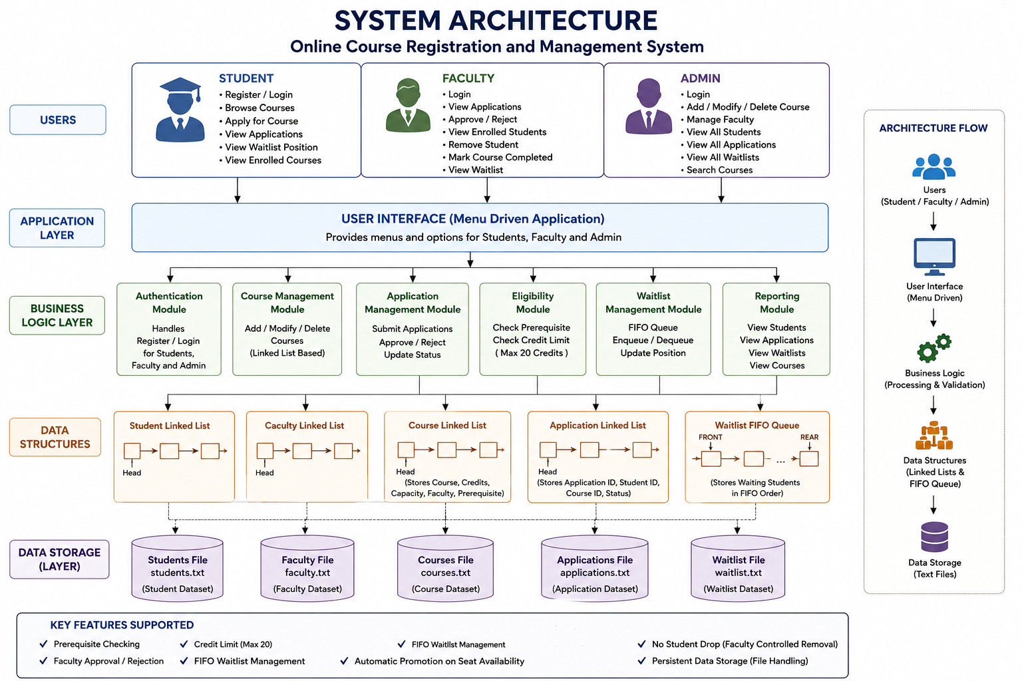
Project Description: (here you write what you did in this project (contribution) including Model Description
The Online Course Registration and Management System is a web-based platform developed to make the course registration process simple, fast, and efficient for students and administrators. Students can create accounts, log in, view available courses, check course details, credits, faculty information, and schedules, and register for their preferred courses online. They can also view their registered courses and cancel registrations when required.Administrators can add, update, and delete courses, manage student information, monitor registrations, and maintain course schedules. The system can also prevent duplicate registrations and help manage course capacity. By replacing traditional manual registration methods with a centralized digital system, the proposed system reduces paperwork, saves time, minimizes errors, and improves the overall efficiency of academic course management.

Student Signature Guide Signature

